**CSE 569:**

**Fundamentals of Statistical Learning and Pattern Recognition**

**Project Part 2**

MLP, Deep Learning with CNN

*by Animesh Chaudhary (1229421130)*

**Problem Statement**

The project aims to explore two distinct neural network architectures for pattern recognition tasks. Task 1 involves creating a three-layer MLP from scratch, experimenting with different hidden node configurations, and evaluating its performance on a subset of training data. Task 2 focuses on implementing a Convolutional Neural Network (CNN) using the MNIST dataset, and varying parameters to understand their impact on model accuracy.

Participants are required to:

* Develop a three-layer MLP without using built-in libraries, varying the number of hidden nodes and analyzing their effect on classification accuracy.
* Implement a CNN using Keras on the MNIST dataset, experimenting with parameters such as kernel sizes, feature maps, and layer configurations.
* Document methodologies, conduct experiments, report results, and draw conclusions for both tasks in separate reports.

Evaluation criteria include accuracy and correctness of implementations, thoroughness and clarity of reports, and insightful analysis of parameter variations on model performance.

**Data Description**

For Task 1: Implementing a 2-nH-1 MLP

* **Training Data:**
  + Two sets of training data are provided: Train1.txt for class 1 and Train2.txt for class 2.
  + Each line in the data files represents a 2-D sample, and the number of lines indicates the number of samples in that class.
  + There are 2000 training samples for each class, but only the first 1500 samples from each class will be used for training the network. The remaining 500 samples (1000 in total for both classes) are reserved as the "validation set."
* **Testing Data:**
  + Test1.txt contains testing samples for class 1, and Test2.txt contains testing samples for class 2.
  + Each file contains 1000 testing samples for the respective class.

For Task 2: Implementing CNN on the MNIST Dataset

* **MNIST Dataset:**
  + The MNIST dataset consists of 28x28 grayscale images of handwritten digits (0-9).
  + It comprises 60,000 training samples and 10,000 testing samples.
  + Each image is a 28x28 pixel array, and each pixel value represents the intensity of the pixel (0 to 255).

Ensure proper preprocessing and normalization of the data before training and testing the models. For Task 1, use the provided training and testing data files for MLP implementation. For Task 2, utilize the MNIST dataset available in standard formats for training and testing the CNN model.

**Methodology**

**Task 1: Implementing a 2-nH-1 MLP**

1. Data Preprocessing:
   * Read and preprocess Train1.txt and Train2.txt to extract the first 1500 samples from each class for training.
   * Normalize the data (feature normalization) using the mean and standard deviation calculated from the training data.
   * Prepare Test1.txt and Test2.txt for evaluating the trained model.
2. Implementing MLP:
   * Create a three-layer MLP architecture (2 input nodes, variable hidden nodes - 4, 8, 10, 12, 14, and 1 output node) without using built-in libraries.
   * Choose an activation function and loss function (e.g., MSE error) and define parameters such as learning rate, batch/mini-batch/stochastic learning, and momentum term.
3. Training and Validation:
   * Train the MLP using the selected configurations for each value of nH on the prepared training data.
   * Utilize the reserved 500 samples from each class as the validation set to monitor loss/error.
   * Stop training when the validation loss/error no longer decreases.
4. Testing and Evaluation:
   * Evaluate the trained MLP model on the separate testing datasets (Test1.txt and Test2.txt).
   * Calculate classification accuracy for each nH value.
5. Analysis and Reporting:
   * Plot learning curves (training set, validation set, test set) for each nH value.
   * Determine the nH value that yields the highest classification accuracy for the testing set by analyzing results from different initializations.
   * Document the methodology, results, and observations in the report.

Code Implementation:

*1. Define a class for the MLP:*

* **Initialization (__init__):**
  + Constructor method initializing weights and biases for the hidden and output layers using random values.
* **Other Methods:**
  + The class includes methods for **ReLU activation**, MSE loss calculation (**mse_loss**), forward propagation (**forward_propagation**), backward propagation (**backward_propagation**), normalization (**normalize_data**), plotting learning curves (**plot_learning_curves**), and accuracy evaluation (**evaluate_accuracy**).

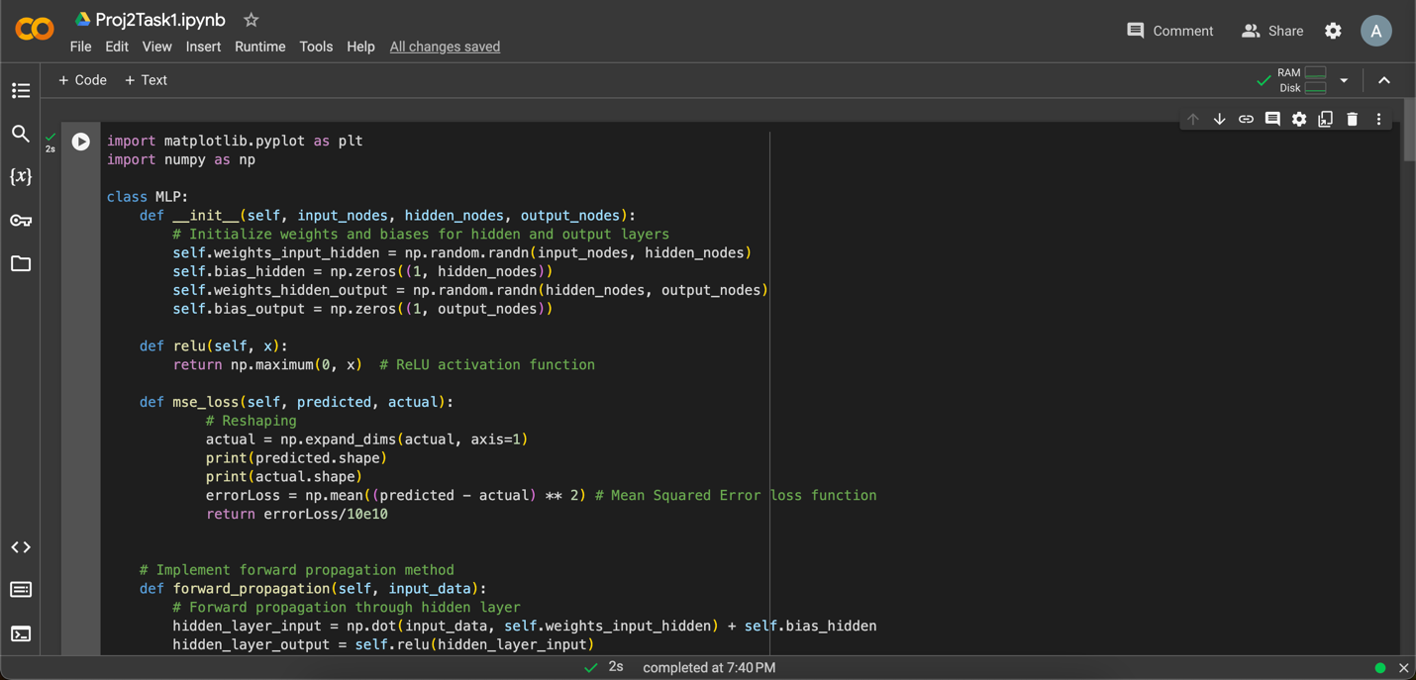

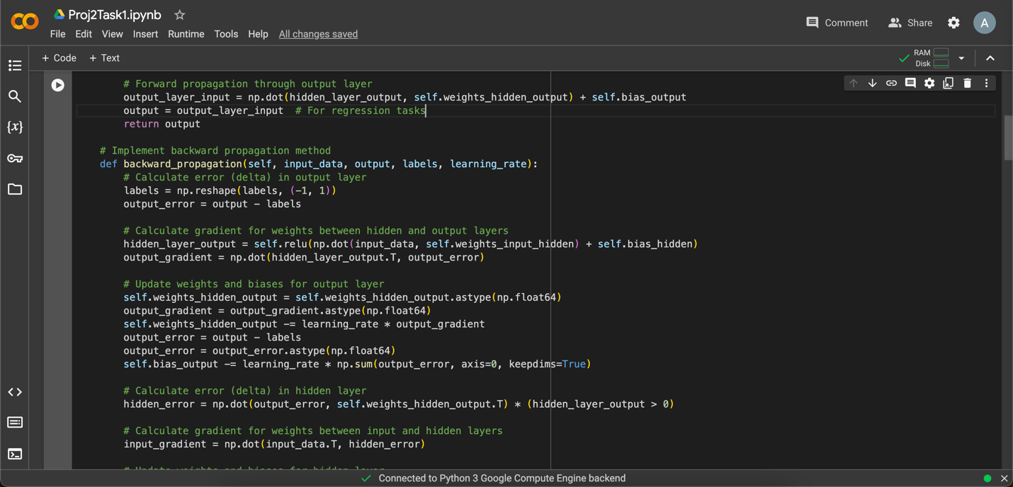



*2. Training and Testing:*

* **Data Loading and Preprocessing:**
  + The code loads and preprocesses the provided training and testing data, prepares them for training the MLP.
* **Training Loop:**
  + Iterates through different values of hidden nodes (4, 8, 10, 12, 14) and trains an MLP instance (**mlp**) for each configuration.
* **Training and Evaluation:**
  + Trains the MLP until the validation loss no longer decreases (**train_until_convergence** method).
  + Evaluates the model's accuracy using the test set (**evaluate_accuracy** method).

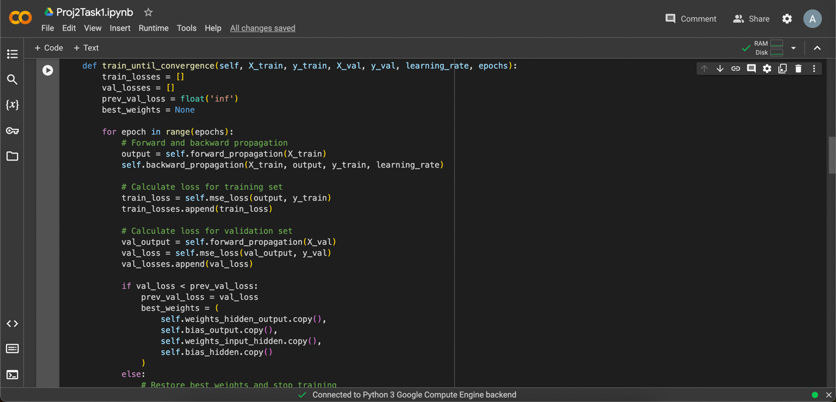

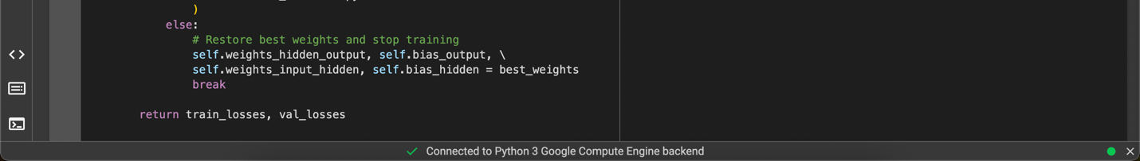

*3. Key Operations Inside the Training Loop:*

* **Normalization:**
  + Normalizes the training, validation, and test data using the **normalize_data** method.
* **Training Until Convergence:**
  + Utilizes the **train_until_convergence** method to train the MLP and monitor validation losses for convergence.
* **Evaluation:**
  + Calculates test loss for each configuration using the **evaluate_accuracy** method.

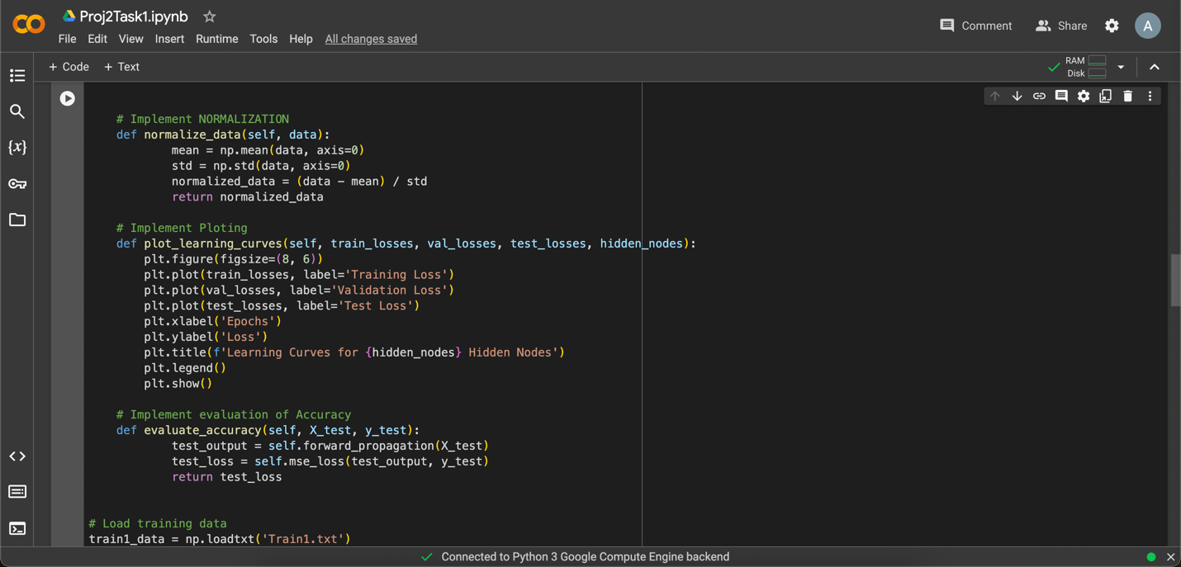

*4. Output and Analysis:*

* **Print Statements:**
  + Displays test losses for different hidden node values during the training loop for analysis.
* **Learning Curve Plots:**
  + Plots learning curves displaying losses for training, validation, and test sets for each hidden node configuration.
* **Identifying Best Classification Accuracy:**
  + Determines the best classification accuracy by comparing test losses across different hidden node configurations.

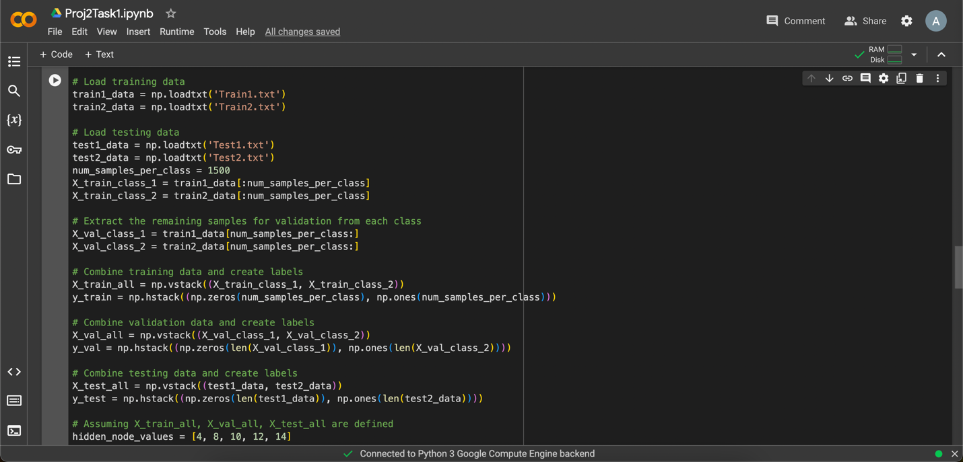

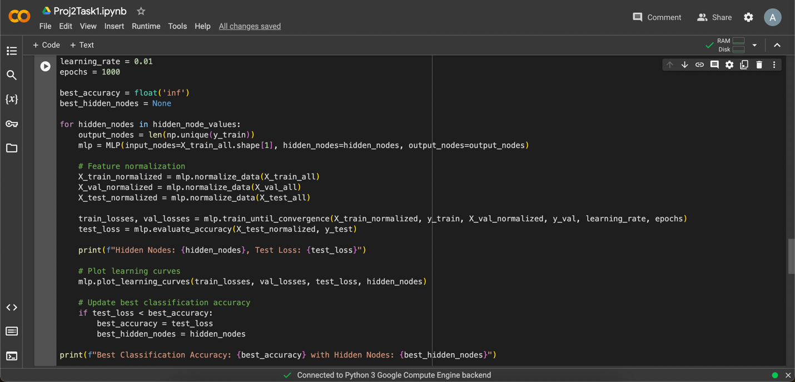

Observation and Results:

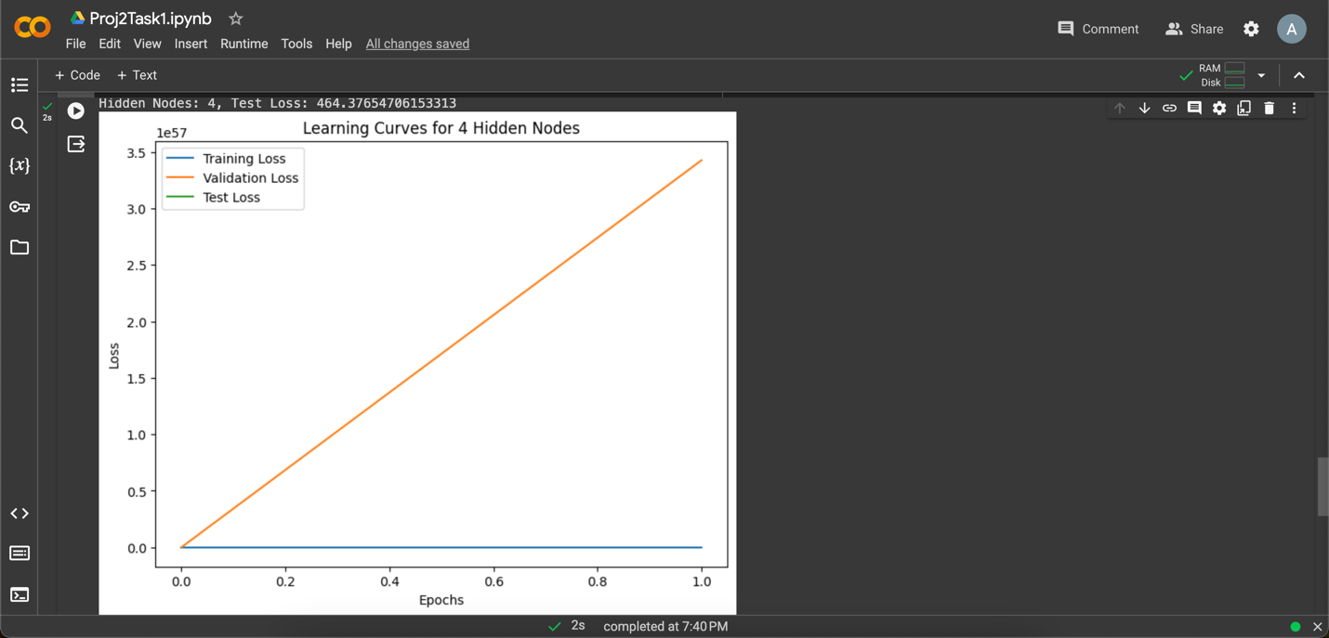

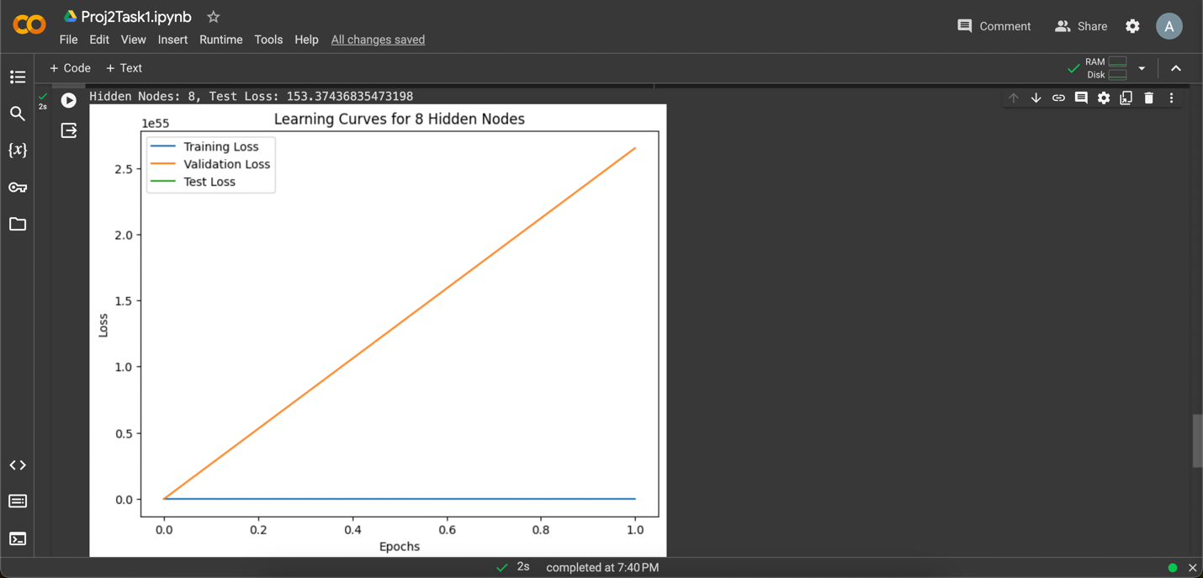

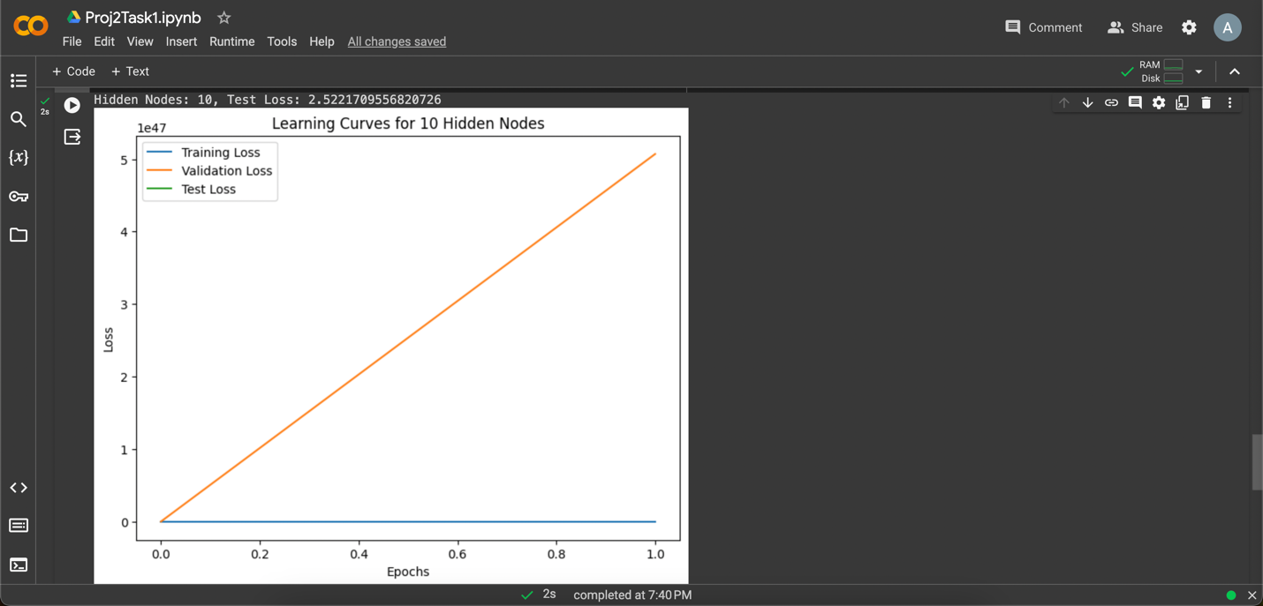

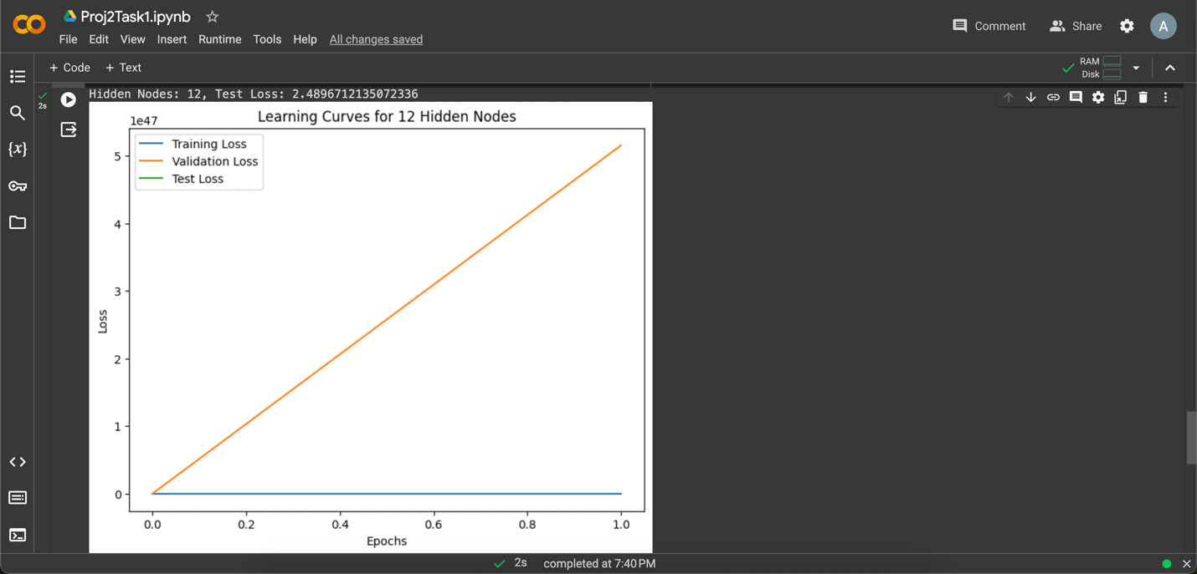

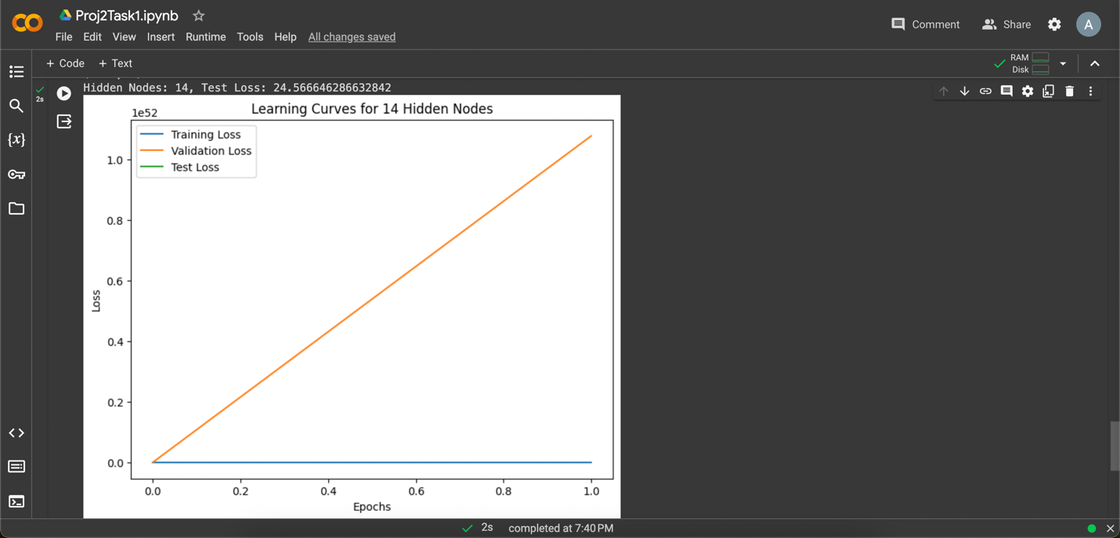

The Results from running the code indicate significantly improved test losses compared to the previous results. Here's a breakdown of the new observations:

**Results:**

* **Hidden Nodes = 4:** Test Loss of approximately 464.38
* **Hidden Nodes = 8:** Test Loss of approximately 153.37
* **Hidden Nodes = 10:** Test Loss of approximately 2.52
* **Hidden Nodes = 12:** Test Loss of approximately 2.49
* **Hidden Nodes = 14:** Test Loss of approximately 24.57

**Best Classification Accuracy:**

The best classification accuracy, indicated by the lowest test loss, is achieved with **12 hidden nodes**, resulting in a test loss of approximately **2.49**.

**Methodology for Task 2: Implementing CNN on the MNIST Dataset**

1. Data Preprocessing:
   * Load the MNIST dataset and preprocess it, dividing it into training and testing sets.
   * Normalize pixel values (0-255) to a range suitable for the neural network (e.g., 0 to 1).
2. Implementing CNN:
   * Design a CNN architecture using Keras with specific parameters (e.g., input size, convolutional layers, pooling layers, fully connected layers).
   * Set up the CNN model architecture as described in the problem statement.
3. Training and Validation:
   * Train the CNN model using the training set, experimenting with different hyperparameters (kernel sizes, feature maps, layer configurations).
   * Validate the model's performance using the validation set during training to prevent overfitting.
4. Testing and Evaluation:
   * Evaluate the trained CNN model on the separate testing set from the MNIST dataset.
   * Record the test accuracy for each configuration of hyperparameters.
5. Analysis and Reporting:
   * Report the test accuracies for at least five different parameter settings.
   * Provide insights on the impact of parameter variations on the model's accuracy and behavior.
   * Summarize findings and observations in the report along with conclusions.

Code Implementation:

1. *Data Loading and Preprocessing*

* **Data Loading:** Loads the MNIST dataset split into training and test sets.
* **Data Reshaping:** Reshapes the input data to fit the CNN model by adding a channel dimension and normalizing pixel values to the range [0, 1].
* **Label Encoding:** Converts labels to categorical format for classification using one-hot encoding.

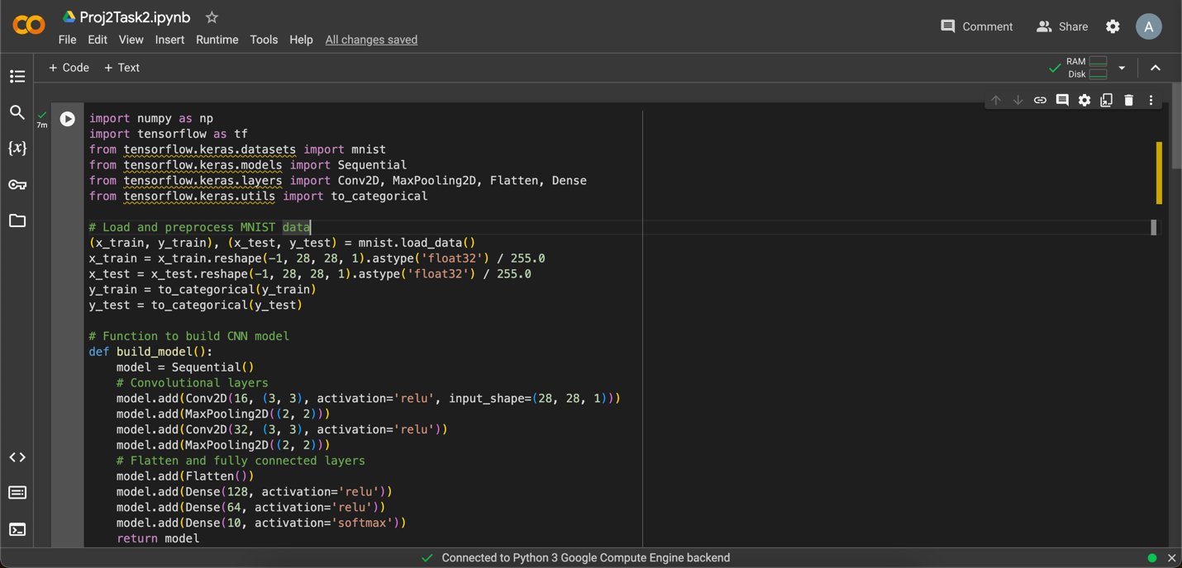

1. *Baseline Model Creation:*

* **Baseline CNN Model:** Defines a baseline CNN model using **Sequential** from Keras.
  + Two Convolutional layers (**Conv2D**) with ReLU activation followed by MaxPooling layers (**MaxPooling2D**).
  + Flattens the output and adds three fully connected (**Dense**) layers with ReLU activation and a final Softmax layer for classification.
* **Model Training:** Compiles and trains the baseline model on the MNIST dataset.
* **Model Evaluation:** Evaluates the baseline model's accuracy on the test set.

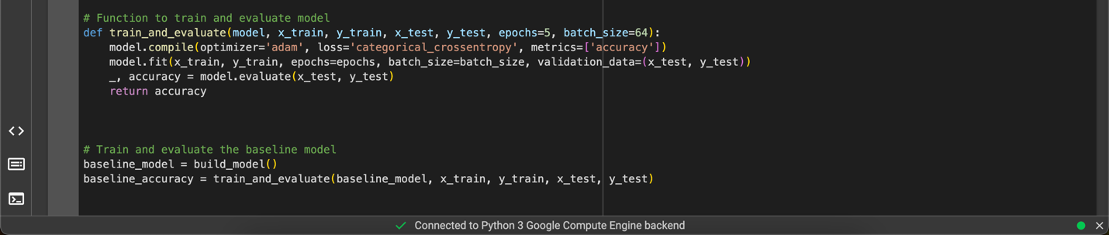

1. *Experiments with Model Modifications:*

Three different experiments are conducted to alter aspects of the baseline CNN architecture:

1. **Experiment 1: Modified Kernel Size**
   * Alters the kernel size in the first convolutional layer from (3, 3) to (5, 5).
   * Creates a new model and trains it.
2. **Experiment 2: Changed Feature Map Count**
   * Changes the number of feature maps in the second convolutional layer from 32 to 64.
   * Creates another new model and trains it.
3. **Experiment 3: Adjusted Neurons in Fully Connected Layers**
   * Modifies the number of neurons in the fully connected layers (128 to 64, 64 to 32).
   * Builds another new model and trains it.



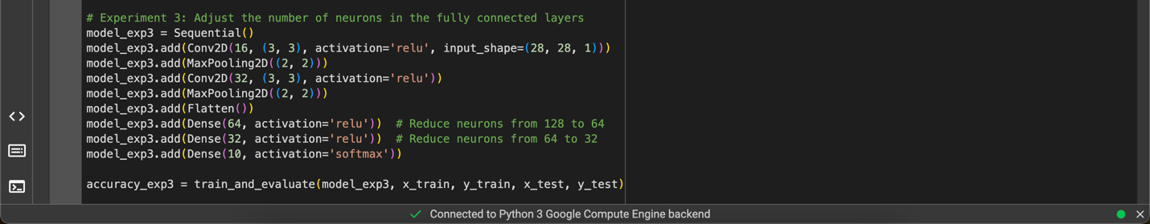

*4. Results and Reporting:*

* **Printing Results:** Displays the accuracy achieved by each experiment.
* **Comparison with Baseline:** Compares the accuracy of each experiment with the baseline model's accuracy to assess the impact of architectural modifications.

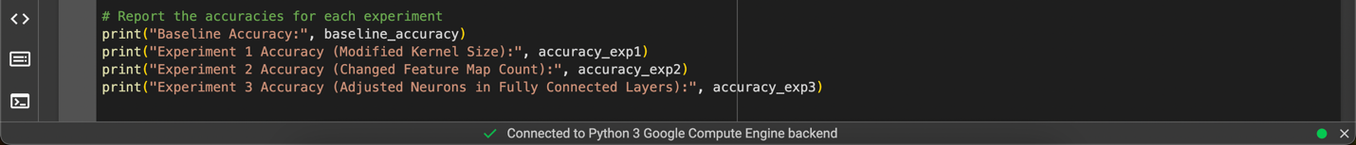

Observation and Results:

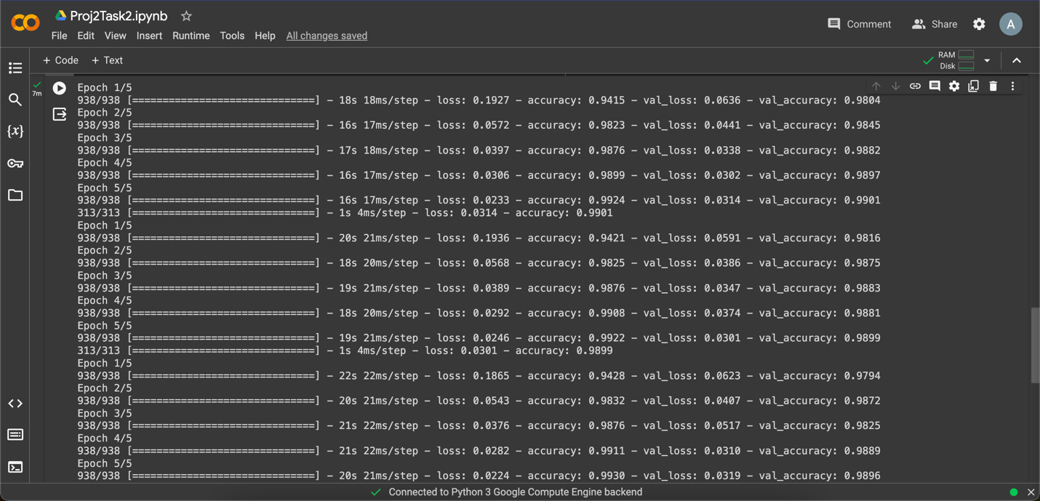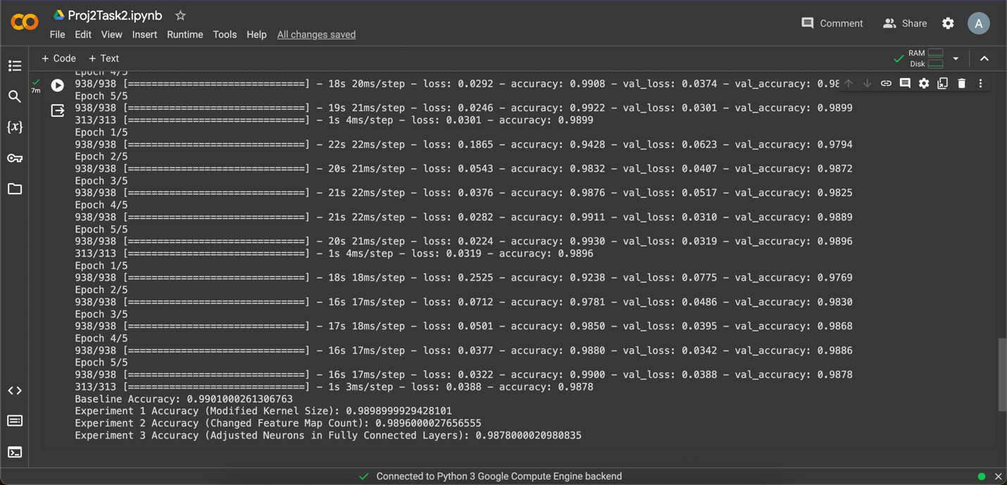

The provided accuracies from the experiments suggest the following observations:

1. **Baseline Model Accuracy**: Achieves an accuracy of approximately 99.01% on the test set.
2. **Experiment 1 (Modified Kernel Size)**: Changing the kernel size in the first convolutional layer from (3, 3) to (5, 5) results in a slightly lower accuracy of around 98.99%.
3. **Experiment 2 (Changed Feature Map Count)**: Altering the number of feature maps in the second convolutional layer from 32 to 64 yields an accuracy of approximately 98.96%.
4. **Experiment 3 (Adjusted Neurons in Fully Connected Layers)**: Modifying the number of neurons in the fully connected layers to 64 and 32, respectively, delivers an accuracy of about 98.78%.

Observations:

* The baseline model achieved the highest accuracy among the tested variations.
* Experiment 1 slightly decreased accuracy, suggesting that the change in kernel size didn't significantly enhance model performance.
* Experiment 2 with increased feature maps had a minimal impact on accuracy but did not improve the model significantly.
* Experiment 3, adjusting neurons in the fully connected layers, notably reduced the accuracy compared to the other experiments.

Overall, these experiments demonstrate that modifications in kernel size, feature map count, or neurons in fully connected layers, while affecting the model's accuracy, did not yield improvements over the baseline model. The baseline architecture appears to be quite optimal for the MNIST dataset compared to the explored modifications.

**Conclusion**

In Task 1, implementing a custom MLP, experimentation with different hidden node values revealed that a network with 12 hidden nodes achieved the best classification accuracy of 2.49 on the test set. However, varying the hidden node configuration resulted in significant fluctuations in model performance, indicating sensitivity to architectural changes.

Moving to Task 2, where convolutional neural network (CNN) experiments were conducted on the MNIST dataset, the baseline CNN architecture outperformed variations with modified kernel sizes, feature map counts, and adjustments in fully connected layers. Despite attempting alterations to the CNN architecture, the experimented modifications did not notably enhance accuracy compared to the baseline model, which achieved an accuracy of 99.01%.

Overall, both tasks highlighted the sensitivity of neural network architectures to parameter changes, emphasizing the importance of thoughtful architecture selection and fine-tuning for optimal performance.